PROFILE

Computer science student.
I consider myself a responsible and orderly person.
I am looking forward to my first work experience.

CONTACT ME

6385621958

praveensaker97484@gmail.

com

278, Main Street Neivasal, Thanjavur, 614019

PRAVEEN S
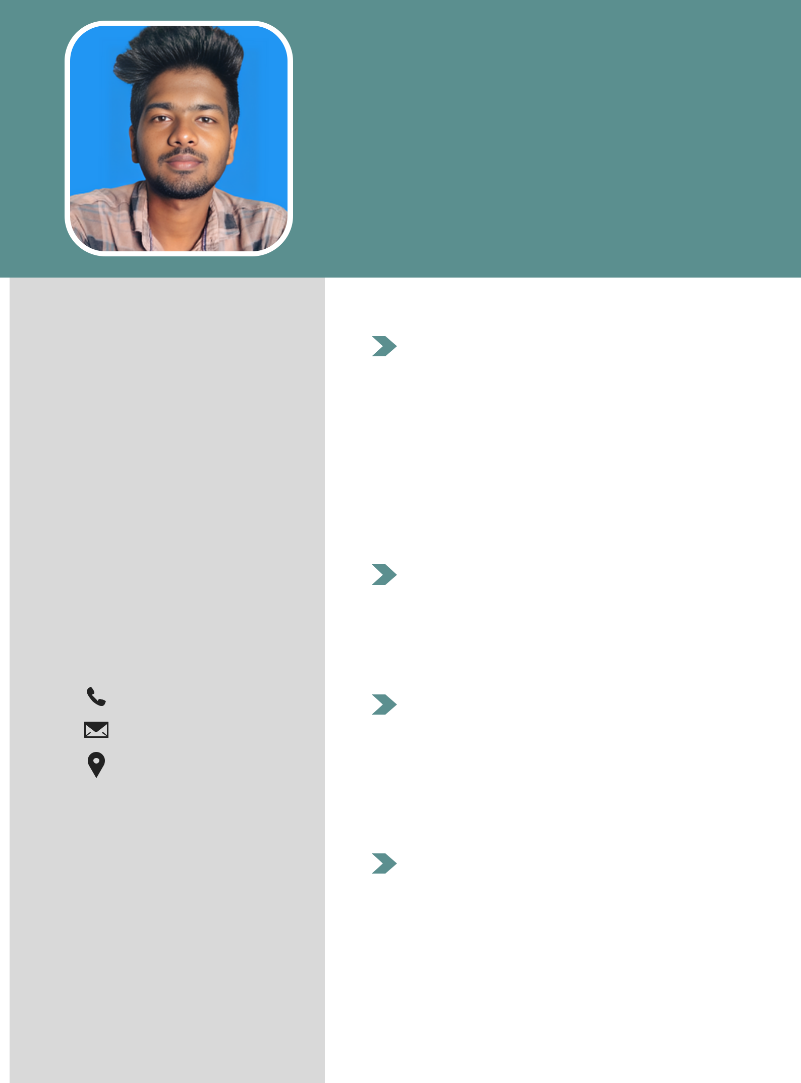

Student

EDUCATION

BHARADHIDHASAN UNIVERSITY COMPUTER SCIENCE career, in

progress.

ANNAI VAILANKANNI ARTS AND SCIENCE COLLEGE 2021-2024

LANGUAGE

Native Tamil.

Advanced English.

COMPUTER SKILLS

Python.

Web designing

Programming.

WORK EXPERIENCE

FRESHER

